1. Design TM using simulator to accept the input string wcw

*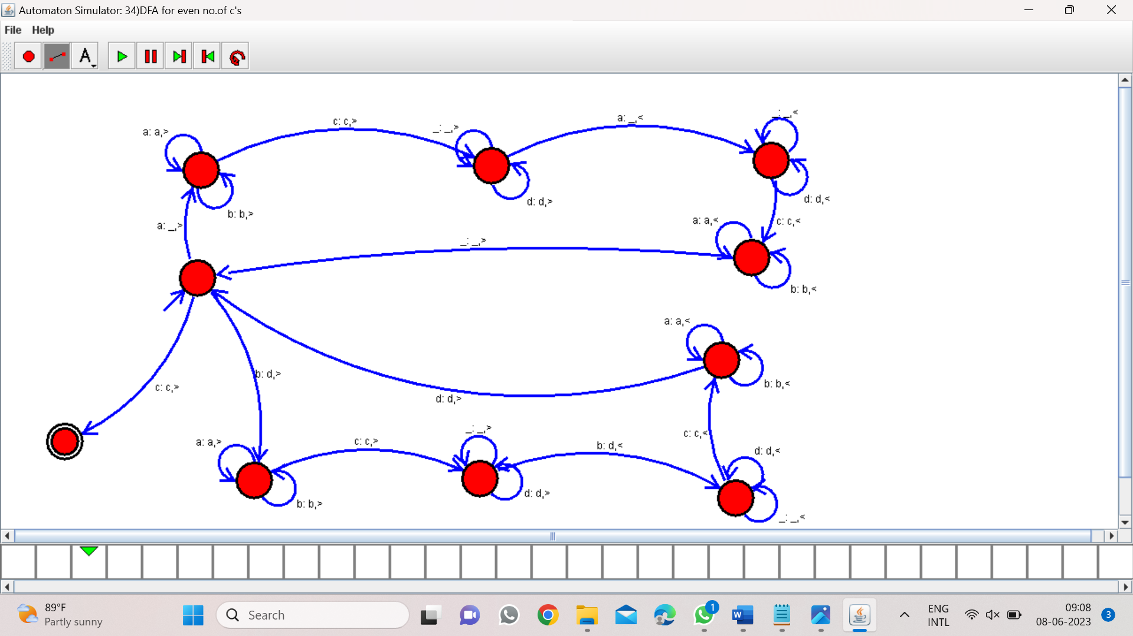*

Result:-

From the above Turing Machine Diagram valid the string of input wcw